Experiment No. 8

Aim: Implementation of a program for designing a GUI using Swing components.

- Implement the following GUI without any IDE
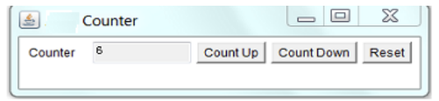

import javax.swing.*;
import java.awt.*;
import java.awt.event.*;

public class CounterGUI extends JFrame implements ActionListener {

JTextField textField;
JButton btnUp, btnDown, btnReset;
int count = 0;

public CounterGUI() {
setTitle("Counter");
setSize(400, 120);
setLayout(new FlowLayout());

JLabel label = new JLabel("Counter");

textField = new JTextField("0", 5);
textField.setEditable(false);

btnUp = new JButton("Count Up");
btnDown = new JButton("Count Down");
btnReset = new JButton("Reset");

add(label);
add(textField);
add(btnUp);
add(btnDown);
add(btnReset);

btnUp.addActionListener(this);
btnDown.addActionListener(this);
btnReset.addActionListener(this);

setDefaultCloseOperation(JFrame.EXIT_ON_CLOSE);
setVisible(true);
}

public void actionPerformed(ActionEvent e) {
if (e.getSource() == btnUp) {
count++;
} else if (e.getSource() == btnDown) {
count--;
} else if (e.getSource() == btnReset) {
count = 0;
}

textField.setText(String.valueOf(count));
}

public static void main(String[] args) {
new CounterGUI();
}
}

OUTPUT:
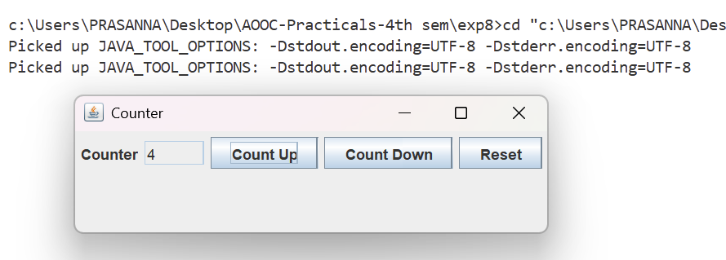

- Write a GUI program to find the reverse of a given number using Swing (with IDE)

import javax.swing.*;
import java.awt.*;
import java.awt.event.*;

public class ReverseNumberGUI extends JFrame implements ActionListener {

JTextField inputField, resultField;
JButton reverseBtn;

public ReverseNumberGUI() {
setTitle("Reverse Number");
setSize(350, 150);
setLayout(new GridLayout(3, 2, 5, 5));

JLabel inputLabel = new JLabel("Enter Number:");
JLabel resultLabel = new JLabel("Reversed Number:");

inputField = new JTextField();
resultField = new JTextField();
resultField.setEditable(false);

reverseBtn = new JButton("Reverse");

add(inputLabel);
add(inputField);
add(resultLabel);
add(resultField);
add(new JLabel()); // empty space
add(reverseBtn);

reverseBtn.addActionListener(this);

setDefaultCloseOperation(JFrame.EXIT_ON_CLOSE);
setVisible(true);
}

public void actionPerformed(ActionEvent e) {
try {
int num = Integer.parseInt(inputField.getText());
int reversed = 0;

while (num != 0) {
int digit = num % 10;
reversed = reversed * 10 + digit;
num = num / 10;
}

resultField.setText(String.valueOf(reversed));

} catch (NumberFormatException ex) {
JOptionPane.showMessageDialog(this, "Please enter a valid number!");
}
}

public static void main(String[] args) {
new ReverseNumberGUI();
}
}

OUTPUT:
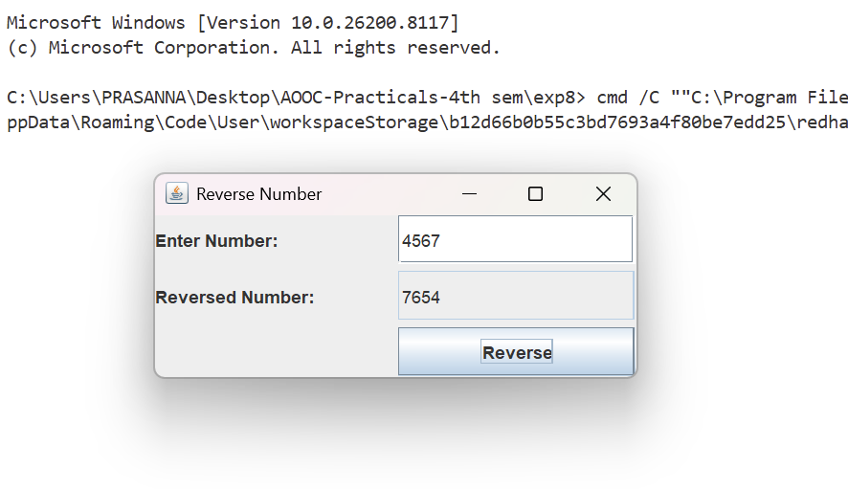

- Write a GUI program to demonstrate the use of radio buttons (e.g., gender selection)

import javax.swing.*;
import java.awt.*;
import java.awt.event.*;

public class GenderGUI extends JFrame implements ActionListener {

JRadioButton male, female, other;
JButton submit;

public GenderGUI() {
setTitle("Gender Selection");
setSize(300, 200);
setLayout(new FlowLayout());

JLabel label = new JLabel("Select Gender:");

// Create radio buttons
male = new JRadioButton("Male");
female = new JRadioButton("Female");
other = new JRadioButton("Other");

// Group them
ButtonGroup bg = new ButtonGroup();
bg.add(male);
bg.add(female);
bg.add(other);

// Button
submit = new JButton("Submit");

// Add components
add(label);
add(male);
add(female);
add(other);
add(submit);

// Action
submit.addActionListener(this);

setDefaultCloseOperation(JFrame.EXIT_ON_CLOSE);
setVisible(true);
}

public void actionPerformed(ActionEvent e) {
String gender;

if (male.isSelected()) {
gender = "Male";
} else if (female.isSelected()) {
gender = "Female";
} else if (other.isSelected()) {
gender = "Other";
} else {
gender = "Not Selected";
}

JOptionPane.showMessageDialog(this, "Selected Gender: " + gender);
}

public static void main(String[] args) {
new GenderGUI();
}
}

OUTPUT :
